**Objective**: Developing a Windows PowerShell script to start **Citrix Broker Service** on remote servers from Terminal Server (Jump-Host) and to collect the output of the Citrix-Windows-PowerShell command **‘Get-BrokerHypervisorConnection’.**

**Pre-requisite**: Terminal Server (Jump-Host) must have below components installed

1. Broker_PowerShellSnapIn_x64 – A PowerShell snap-in for Citrix Servers.
2. Windows PowerShell 2.0 and above.
3. A text file named as ‘list.txt’ saved/kept in the same folder or, location where PowerShell script will be kept and running. PowerShell script has the extension as *.ps1
4. Terminal Server (Jump-Host) must have the required ports open to access Citrix Servers.

**How it works:**

This PowerShell script shows the status of ‘CitrixBrokerService’ on the servers provided in the input file called ‘list.txt’. It shows service is running or stopped. To continue further, script asks to ‘enter key’ to start the ‘CitrixBrokerService’ on the servers mentioned in ‘list.txt’ input file. Once user hits ‘enter’, script starts the service one first server and wait for 15 minutes before it starts service on next server. At end, script runs ‘Get-BrokerHypervisorConnection’ and generates and html file on the same folder\location where script is kept and running.

**How to run the script:**

In this document for the sake of understanding I am assuming the script file(.ps1) and input file(list.txt) are kept at C:\Scripts\CTX on Terminal Server.

1. Open the folder where *.ps1 file is kept. Here, we open the folder C:\Scripts\CTX.

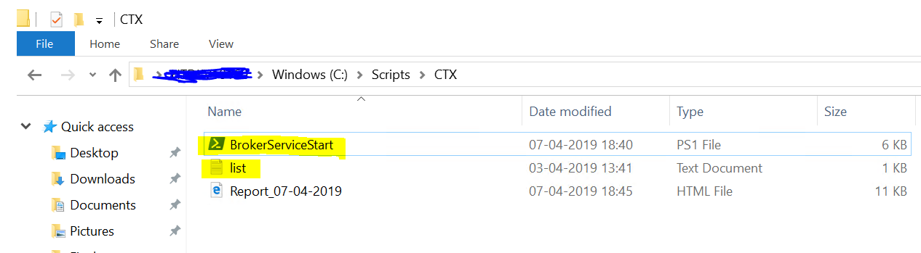

1. Verify the list.txt file is kept at the same location and it has server names correctly written.

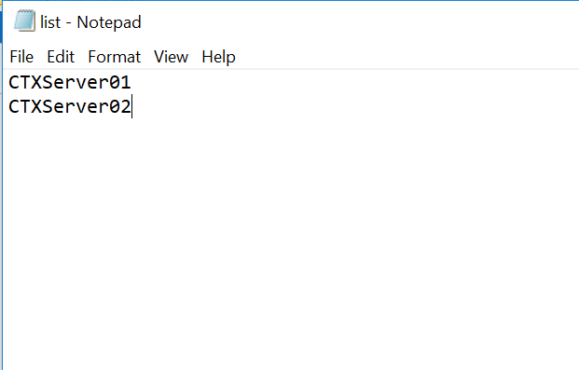

1. Double click the *.ps1 file and wait for few seconds.
2. This will pop-up a command window and show the status of ‘CitrixBrokerService’ on the mentioned servers in list.txt file.

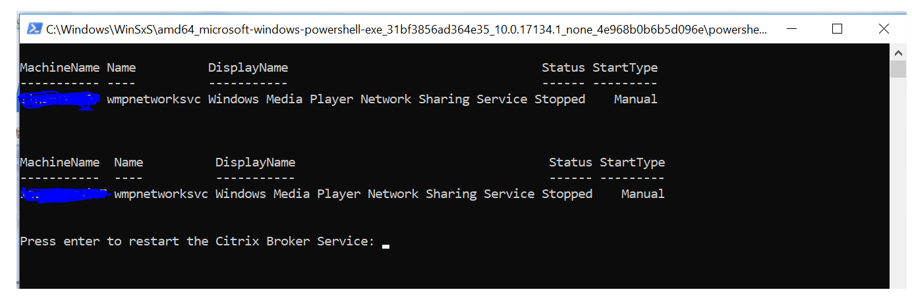

1. After viewing the status, if you want to proceed with start the service, Press ‘Enter’
2. At the next line, it will start the service on one server and wait for 15 mins to start the service on another server.
3. It will display the status of services for all servers one by one.

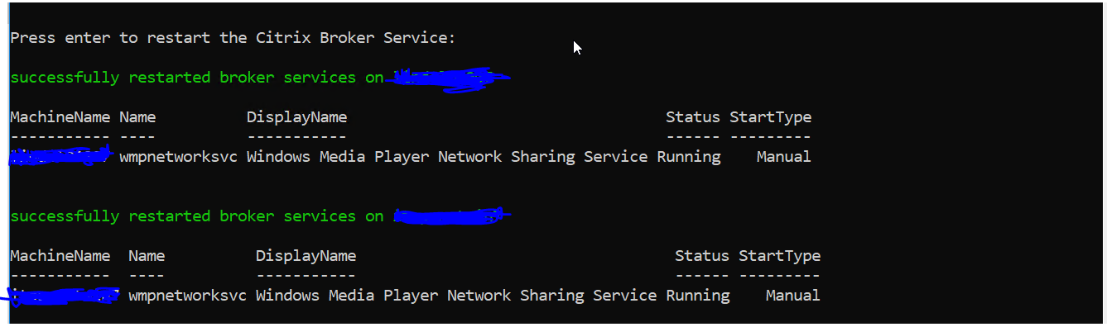

1. After starting the services on all servers, the pop-up window will be closed.
2. The output file is saved at the same location where the script is kept. Here, the output file will be saved at C:\Scripts\CTX.

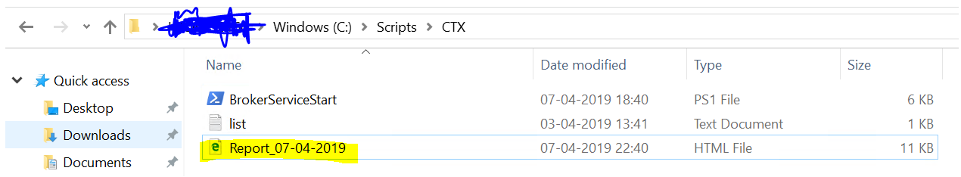

1. The output file is an HTML file and it has the name called ‘Report_CurrentDate’ like Report_07-04-2019

